OPTIMISTIC ALLOCATION OF EXAM CENTERS USING
GOOGLE MAPS API



Submitted to

The Faculty of Engineering and Technology of
Kakatiya University, Warangal
In partial fulfillment of the requirements
To award
Bachelor of Technology
in
Computer Science & Engineering

By

Under the Guidance of
N. C. SANTOSH KUMAR

Department of Computer Science & Engineering
Kakatiya Institute of Technology & Science
Warangal, Telangana, 506015.
2014 – 2015

KAKATIYA INSTITUTE OF TECHNOLOGY & SCIENCE
(Sponsored by Ekasila Education Society, Warangal)
(Affiliated to Kakatiya University, Warangal)(Approved by AICTE, New Delhi)
Opp: Yerragattu Hillock, Vill: Bheemaram, Mandal: Hasanparthy, Warangal – 506015. A.P.

CERTIFICATE

This is to certify that Name of IV/IV b.Tech has satisfactorily completed the dissertation work entitled “optimistic alloCation of exam centers using google maps api” in the partial fulfillment of the requirement of B.Tech degree during academic 2014-2015.

Supervisor Head of the Department
N.C. SANTOSH KUMAR Dr. P. NIRANJAN

External Examiner

ACKNOWLEDGEMENT

I thank the almighty for giving me the courage and perseverance in completing the project. This project itself is an acknowledgement for all those people who have given us their co-operation in making this project a success.
I owe my gratitude to our Principal Dr. K. Ashoka Reddy, Principal, for his attention and valuable guidance to me throughout the course.
I am greatly indebted to Sri. Dr. P. Niranjan, Head of department of CSE for his valuable advices at every stage of this work.
I am also thankful to Mr. N.C.Santosh Kumar, Assistant Professor and Project Coordinator for his valuable advices at every stage of this work. Without their supervision and many hours of devoted guidance, stimulating and constructive criticism, this thesis would never have come out in this form.
Last but not the least, I would like to express my deep sense of gratitude and earnest thanks giving to my dear parents for their moral support and heartfelt co-operation in doing the project. I would also like to thank all the teaching and non teaching staff and my friends, whose direct or indirect help has enabled me to complete this work successfully.

OPTIMISTIC ALLOCATION OF EXAM CENTERS USING
GOOGLE MAPS API

INDEX
Contents Page No.
Abstract
- Introduction 10
- Literature survey 11
- System Analysis & Design 12
3.1. Problem Analysis 13
3.1.1 Existing system 13
3.1.2 Proposed system 14
3.1.3 Scope 14
3.2. System Study 15
3.2.1 Feasibility study 15
3.2.1.1 Economical Feasibility 15
3.2.1.2 Technical Feasibility 15
3.2.1.3 Operational Feasibility 16
3.3. Minimal Requirements
3.3.1 Hardware requirements 17
3.3.2 Software requirements 17
3.4. Technology Description 18
3.5. Diagrams 32
3.5.1. Data flow diagrams 34
3.5.2. E-R diagrams 38
3.5.3. UML diagrams 39
3.6. Data Tables (Normalized) 48

- Algorithm
4.1 DBSCAN 51
4.2 Why DBSCAN over other 52
4.3 What is DBSCAN 53
4.4 DBSCAN Algorithm 54

- Implementation 57
4.1. Module description 57
4.2. Sample code 58

- Screen Shots 67
5.1 Screens 68
- Testing 73
6.1 Test cases 77
- Conclusion & Future work 80
- Bibliography 83

ABSTRACT
ABSTRACT

In India, Competitive Examinations are regularly conducted to promote students. Such examinations are conducted in various parts of the state/country where students now-a-days are instructed to apply online to register their names to take part in competition. Once the registration process is completed, organizers of such examinations have to make rich endeavors to allocate examination centers. To allocate Centers for Examinations which are conducted State-Wide (EAMCET, APSET, ICET) or National-Wide (GATE, NET, AIEEE etc..,), a rigorous ground work is required to check the total number of students appearing for the examination, total number students belonging to diverse geographic locations. So that the examinations are conducted in an optimistic manner keeping in view the expenditure for the conduction of examination. We propose a novel approach to automate this process of allocation of exam centers optimistically. In this project named “Optimistic Allocation of Exam Centers using Google Maps API”, which guarantees the generation and representation of optimistic allocation of exam centers on google maps based on registered candidates for that exam.

INTRODUCTION

1. INTRODUCTION

In India, Competitive Examinations are regularly conducted to promote students for higher education and also for assessment of students to get their eligibility for lecturer ship in Universities and research aspects. Such examinations are conducted in various parts of the state/country where students now-a-days are instructed to apply online to register their names to take part in competition.
Once the registration process is completed, organizers of such examinations have to make rich endeavors to allocate examination centers. To allocate Centers for Examinations which are conducted State-Wide (EAMCET, APSET, ICET) or National-Wide (GATE, NET, AIEEE etc..,), a rigorous ground work is required to check the total number of students appearing for the examination, total number students belonging to diverse geographic locations. So that the examinations are conducted in an optimistic manner keeping in view the expenditure for the conduction of examination.
We propose a novel approach to automate this process of allocation of exam centers optimistically. In this project named “Optimistic Allocation of Exam Centers using Google Maps API”, which guarantees the generation and representation of optimistic allocation of exam centers on google maps based on registered candidates for that exam.

2. LITERATURE SURVEY

Literature survey is the most important step in software development process. Before developing the tool it is necessary to determine the time factor, economy and company strength. Once these things are satisfied, ten next steps are to determine which operating system and language can be used for developing the tool. Once the programmers start building the tool the programmers need lot of external support. This support can be obtained from senior programmers, from book or from websites. Before building the system the above consideration are taken into account for developing the proposed system.

The Optimistic Allocation of Exam Centers using Google Maps API System introduced in this chapter is positioned right in between the sticky notes on your monitor and an advanced Allocation system manager application. This system manager will search for registered candidates in this application. First any user should be register in our Site whoever already ready register they will get password and username, by using their credentials they will see they own content. The site mainly developed for Allocating exam centers by clustering registered candidates addresses.

System Analysis & Design
3. System Analysis & Design

3.1. Problem Analysis

    - EXISTING SYSTEM:

The Controllers of Examinations usually allocate the examination centers for the competitive exams manually which is a very complex process involving various tasks. After the completion of online registration process, the tasks like clustering of all registrations of candidates from various geographical locations is done followed by the task of estimating the exam centers and the required invigilators for the conduction of the exam.

SOLUTION OF THESE PROBLEMS:

The development of the new system contains the following activities, which try to automate the entire process keeping in view of the database integration approach.
- User friendliness is provided in the application with various controls.
- The system makes the overall project management much easier and flexible.
- Readily upload the latest updates, allows user to download the alerts by clicking the URL.
- There is no risk of data mismanagement at any level while the project development is under process.
It provides high level of security with different level of authentication.

3.1.2 PROPOSED SYSTEM:
In this project, we automate the process of allocation of centers optimally based on Google maps. This system enables the controller of the examinations:
-To check the total number of registered candidates.
-To check the total number of registered candidates based on their geographical location.
-To create the optimal exam centers based on the density of the appearing candidates.
-To estimate the faculty/invigilators required for the smooth conduction of the examination.

Advantages of Proposed System:
Advantages of a spatial data approach that analyzes the aggregate locations reported from the maps through online with Internet. The estimated distribution is used to provide location monitoring services through answering range queries. We evaluate our system through simulated experiments. The results show that our system provides high quality location monitoring services while preserving them monitored object’s location privacy.

3.1.3 Scope:
This project is aimed at developing a repository for optimistic allocation of exam centers on google maps, which is of importance to examination controllers of andhrapradesh. This application is a web based application that can be accessed throughout this state. Anyone can access the search Engine to know about this web application, any student can easily register for any exam based on his eligibility criteria, and also he can update his details.

3.2 System Study:
3.2.1 Feasibility Study:
3.2.1.1 Economical Feasibility:
Economic feasibility attempts 2 weigh the costs of developing and implementing a new system, against the benefits that would accrue from having the new system in place. This feasibility study gives the top management the economic justification for the new system. A simple economic analysis which gives the actual comparison of costs and benefits are much more meaningful in this case. In addition, this proves to be a useful point of reference to compare actual costs as the project progresses. There could be various types of intangible benefits on account of automation. These could include increased customer satisfaction, improvement in product quality better decision making timeliness of information, expediting activities, improved accuracy of operations, better documentation and record keeping, faster retrieval of information, better employee morale.
3.2.1.2 Technical Feasibility:
Evaluating the technical feasibility is the trickiest part of a feasibility study. This is because, at this point in time, not too many-detailed design of the system, making it difficult to access issues like performance, costs on (on account of the kind of technology to be deployed) etc. A number of issues have to be considered while doing a technical analysis.
Understand the different technologies involved in the proposed system:
Before commencing the project, we have to be very clear about what are the technologies that are to be required for the development of the new system.
Find out whether the organization currently possesses the required technologies:
Is the required technology available with the organization?
If so is the capacity sufficient?
For instance – “Will the current printer be able to handle the new reports and forms required for the new system?”

3.2.1.3 Operational Feasibility:
Proposed projects are beneficial only if they can be turned into information systems that will meet the organizations operating requirements. Simply stated, this test of feasibility asks if the system will work when it is developed and installed. Are there major barriers to Implementation? Here are questions that will help test the operational feasibility of a project:
- Is there sufficient support for the project from management from users? If the current system is well liked and used to the extent that persons will not be able to see reasons for change, there may be resistance.
- Are the current business methods acceptable to the user? If they are not, Users may welcome a change that will bring about a more operational and useful systems.
- Have the user been involved in the planning and development of the project? Early involvement reduces the chances of resistance to the system and in General and increases the likelihood of successful project.
Since the proposed system was to help reduce the hardships encountered In the existing manual system, the new system was considered to be operational feasible.

3.3. Minimal Requirements:

3.3.1 Hardware requirements:

Processor : Core i3 processor
RAM : 4GB
Hard Disk : 500GB
Monitor : 15” color monitor
Keyboard : Multimedia key board

3.3.2 Software requirements:

Operating System : Windows 2007 ultimate
Front End Tool (software specification) : PHP
Back End Tool (database) : MySQL
Language : PHP

3.4 . Technology Description:
FRONT-END

What is HTML?
HTML is a language for describing web pages.
- HTML stands for Hyper Text Markup Language
- HTML is a markup language
- A markup language is a set of markup tags
- The tags describe document content
- HTML documents contain HTML tags and plain text
- HTML documents are also called web pages

HTML Tags
HTML markup tags are usually called HTML tags
- HTML tags are keywords (tag names) surrounded by angle brackets like <html>
- HTML tags normally come in pairs like <b> and </b>
- The first tag in a pair is the start tag, the second tag is the end tag
- The end tag is written like the start tag, with a forward slash before the tag name
- Start and end tags are also called opening tags and closing tags
<tagname>content</tagname>

HTML Page Structure
Below is a visualization of an HTML page structure:
<html>
<body>
<h1>This a heading</h1>
<p>This is a paragraph.</p>
<p>This is another paragraph.</p>
</body>
</html>

Writing HTML Using Notepad or Text Edit
HTML can be edited by using a professional HTML editor like:
- Adobe Dreamweaver
- Microsoft Expression Web
- Coffee Cup HTML Editor
However, for learning HTML we recommend a text editor like Notepad (PC) or Text Edit (Mac). We believe using a simple text editor is a good way to learn HTML.
Follow the 4 steps below to create your first web page with Notepad.

Step 1: Start Notepad
To start Notepad go to:
Start
All Programs
Accessories
Notepad
Step 2: Edit Your HTML with Notepad
Type your HTML code into your Notepad:
Step 3: Save Your HTML
Select Save as.. in Notepad's file menu.
When you save an HTML file, you can use either the .html or the .html file extension. There is no difference; it is entirely up to you.
Step 4: Run the HTML in Your Browser
Start your web browser and open your html file from the File, Open menu, or just browse the folder and double-click your HTML file.
Java script introduction
JavaScript is the world's most popular programming language. It is the language for HTML and the web, for servers, PCs, laptops, tablets, smart phones, and more.

JavaScript is a Scripting Language
A scripting language is a lightweight programming language.
JavaScript is programming code that can be inserted into HTML pages.
JavaScript inserted into HTML pages, can be executed by all modern web browsers.
JavaScript is easy to learn.
JavaScript in HTML must be inserted between <script> and </script> tags.
JavaScript’s can be put in the <body> and in the <head> section of an HTML page.

The <script> Tag
To insert a JavaScript into an HTML page, use the <script> tag.
The <script> and </script> tells where the JavaScript starts and ends.
The lines between the <script> and </script> contain the JavaScript:

JavaScript Functions and Events
We want to execute code when an event occurs, like when the user clicks a button.
If we put JavaScript code inside a function, we can call that function when an event occurs.

JavaScript in <head> or <body>
You can place an unlimited number of scripts in an HTML document.
Scripts can be in the <body> or in the <head> section of HTML, and/or in both.
It is a common practice to put functions in the <head> section, or at the bottom of the page. This way they are all in one place and do not interfere with page content.

INTRODUCTION TO PHP

Rasmus Lerdorf wrote the first PHP - first called Personal Home Page - scripts as a series of Perl scripts that he used to track visitors to his webpage and to see who was viewing his resume. He eventually rewrote PHP as a scripting engine and added support for forms. Over the years the Personal Home Page acronym was dropped and it evolved into the PHP Hypertext. PHP can be used to create web applications ranging from personal websites to e-commerce applications and community web portals i.e. discussion forums, blogs etc.

What is PHP?
- PHP stands for PHP: Hypertext Preprocessor
- PHP is a widely-used, open source scripting language
- PHP scripts are executed on the server
- PHP is free to download and use

What is a PHP File?
- PHP files can contain text, HTML, JavaScript code, and PHP code
- PHP code are executed on the server, and the result is returned to the browser as plain HTML
- PHP files have a default file extension of ".php"

What Can PHP Do?
- PHP can generate dynamic page content
- PHP can create, open, read, write, and close files on the server
- PHP can collect form data
- PHP can send and receive cookies

- PHP can add, delete, modify data in your database
- PHP can restrict users to access some pages on your website
- PHP can encrypt data
With PHP you are not limited to output HTML. You can output images, PDF files, and even flash movies. You can also output any text, such as XHTML and XML.

Why PHP?
- PHP runs on different platforms (Windows, Linux, Unix, Mac OS X, etc.)
- PHP is compatible with almost all servers used today (Apache, IIS, etc.)
- PHP has support for a wide range of databases
- PHP is free. PHP is easy to learn and runs efficiently on the server side
PHP INSTALLATION

What do I need?
To start using PHP, you can:
- Find a web host with PHP and MySQL support
- Install a web server on your own PC, and then install PHP and MySQL

Use a web host with php support
If your server has activated support for PHP you do not need to do anything.
Just create some .php files, place them in your web directory, and the server will automatically parse them for you.
You do not need to compile anything or install any extra tools.

Because PHP is free, most web hosts offer PHP support.

Set up php on your own pc
However, if your server does not support PHP, you must:
- install a web server
- install PHP
- install a database, such as MySQL
The PHP script is executed on the server, and the plain HTML result is sent back to the browser.

Basic PHP Syntax
A PHP script can be placed anywhere in the document.
A PHP script starts with <?php and ends with ?>:
<? php
// PHP code goes here
?>
The default file extension for PHP files is ".php".
A PHP file normally contains HTML tags, and some PHP scripting code.

PHP Variables
As with algebra, PHP variables can be used to hold values (x=5) or expressions (z=x+y).
Variable can have short names (like x and y) or more descriptive names (age, car name, total volume).
Rules for PHP variables:
- A variable starts with the $ sign, followed by the name of the variable
- A variable name must begin with a letter or the underscore character
- A variable name can only contain alpha-numeric characters and underscores (A-z, 0-9, and _ )
- A variable name should not contain spaces
- Variable names are case sensitive ($y and $Y are two different variables)

PHP Variable Scopes
The scope of a variable is the part of the script where the variable can be referenced/used.
PHP has four different variable scopes:
- local
- global
- static
- parameter

Local Scope
A variable declared within a PHP function is local and can only be accessed within that function:

Global Scope
A variable that is defined outside of any function has a global scope.
Global variables can be accessed from any part of the script, EXCEPT from within a function.
To access a global variable from within a function, use the global keyword:

Static Scope
When a function is completed, all of its variables are normally deleted. However, sometimes you want a local variable to not be deleted.
To do this, use the static keyword when you first declare the variable:

Parameter Scope
A parameter is a local variable whose value is passed to the function by the calling code.
Parameters are declared in a parameter list as part of the function declaration:

Advantages of PHP Programming
The main advantages of PHP programming include the following:

Open Source
PHP is freely available for use. The community of open source PHP developers provides technical support and is constantly improving updating the core PHP functionalities. PHP is available at free of cost under PHP General Public License and most of its associative required software's like MySQL, Text Editors and Apache Server are also freely available, so it proves very cost effective for the developers.
Cross-Platform
PHP provides high compatibility with leading operating systems and web servers such as thereby enabling it to be easily deployed across several different platforms. PHP scripts can run across operating systems such as Linux, Windows, Solaris, Open BSD, Mac OSX etc and also provide support for all major web servers such as Apache, IIS, iPlanet etc.

Power
Several web tasks can now be easily performing using PHP. For example now we can develop from small websites to giant business and organizational websites, informative forums, chatting platforms, CRM solutions, e-commerce shopping carts, community websites, e-business, shopping carts and gigantic database driven sites.

User Friendly
Designed in a user friendly manner, PHP gives more flexibility than C, C++ and ASP and overall helps in increasing traffic to the site.
Quick
PHP is designed to work well with the web, and so things like accessing the GET and POST and working with HTML and URLs are built-ins in the PHP language. This makes it really concise and straightforward to make a website.
Extensions
Being an open source language, a large number of libraries and extensions, to extend its core functionalities, are available for download. The source code of PHP can be modified to include custom created extensions and components thereby increasing its extensibility.

Easy Deployment
There are many hosting companies that will, for a few dollars a month, give you a server running PHP so you can make a website really easily.
Automatically Refreshes
Nowadays developing dynamic websites are in the huge demand due to its specific characteristics like it automatically refreshes and does not need to make much changes manually.
Community Support

A huge advantage that PHP offers is its community. If you are looking for a particular script, chances are another user has already created something similar. Check within the PHP community for availability. Likewise, if you have created a function that others might enjoy, be sure to post the code for others.
Other Tools
If you need to access other web based tools like Google maps (which is always advisable for a business website), or any other, PHP makes it easy to access.
Security
PHP offers security as well that helps prevent malicious attacks. These security levels can be adjusted in the .ini file.
Talent Availability
You can hire PHP programmers more easily than any other language programmers since so many people know the language.
Summary
- Open Source, PHP is completely free.
- PHP can be easily embedded directly into HTML.
- Platform independent can run on Windows Linux or Mac servers.
- Run faster on the internet and easily integrate AJAX, Callback etc.
- Interfaces very easily with Apache/MySQL
- Lots of good books and on-line help.
- It's available with documentation in many languages.
- Easy to learn compared to many other scripting languages. It has a syntax that is easy to parse and is actually rather human-friendly.
- Lots of hosting services have it ready to use, no special configuration.
- Pretty easy to access other web-based tools through PHP i.e. google maps, etc.

- Lots of good source code out there to use and/or learn from, as well as many useful libraries for working with PDFs, graphics, etc.

BACK-END

What is MySQL?
- MySQL is a database system used on the web
- MySQL is a database system that runs on a server
- MySQL is ideal for both small and large applications
- MySQL is very fast, reliable, and easy to use
- MySQL supports standard SQL
- MySQL compiles on a number of platforms
- MySQL is free to download and use
- MySQL is developed, distributed, and supported by Oracle Corporation
- MySQL is named after co-founder Monty Widenius's daughter: My
The data in MySQL is stored in tables. A table is a collection of related data, and it consists of columns and rows.
Databases are useful when storing information categorically. A company may have a database with the following tables:
- Employees
- Products
- Customers
- Orders

PHP + MySQL

- PHP combined with MySQL are cross-platform (you can develop in Windows and serve on a Unix platform)

Queries
A query is a question or a request.
We can query a database for specific information and have a record set returned.
Look at the following query (using standard SQL):
SELECT Last Name FROM Employees
The query above selects all the data in the "Last Name" column from the "Employees" table.

Facts About MySQL Database
One great thing about MySQL is that it can be scaled down to support embedded database applications. Maybe it is because of this many people think that MySQL can only handle small and medium-sized systems.
Use the PHP mysqli_connect () function to open a new connection to the MySQL server.
Open a Connection to the MySQL Server
Before we can access data in a database, we must open a connection to the MySQL server.
In PHP, this is done with the mysqli_connect () function.

Syntax
mysqli_connect (host, username, password, dbname);

General Commands
USE database name Change to this database. You need to change to some database when you first connect to MySQL.
SHOW DATABASES Lists all MySQL databases on the system.
SHOW TABLES [FROM database name] Lists all tables from the current database or from the database given in the command.
DESCRIBE table name SHOW FIELDS FROM table name
SHOW COLUMNS FROM table name
These commands all give a list of all columns (fields) from the given table, along with column type and other info.
SHOW INDEX FROM table name
Lists all indexes from these tables.
SET PASSWORD=PASSWORD ('new password') Allows the user to set his/her own password.

3.5 Diagrams
3.5.1 Data Flow Diagrams:
The DFD is also called as bubble chart. It is a simple graphical formalism that can be used to represent a system in terms o the input data to the system, various processing carried out on these data, and the output data is generated by the system.
The DFD is one of the most important modeling tools. It is used to model the system components. These components are the system process, the data used by the process, an external entity that interacts with the system and the information flows in the system.
The DFD shows how the information moves through the system and how it is modified by a series of transformations. It is a graphical technique that depicts information flow and the transformations that are applied as data moves from input to output.
The DFD is also known as bubble chart. A DFD may be used to represent a system at any level of abstraction. DFD may be portioned into levels that represent increasing information flow and functional details.

NOTATION:
SOURCE OR DESTINATION OF DATA:
External sources or destinations, which may be people or organizations or other entities.

PROCESS:
People, procedures or devices that produce data. The physical component is not identified.

DATA FLOW:
Data moves in a specific direction from an origin to a destination. The data flow is a “packet” of data

Architecture:

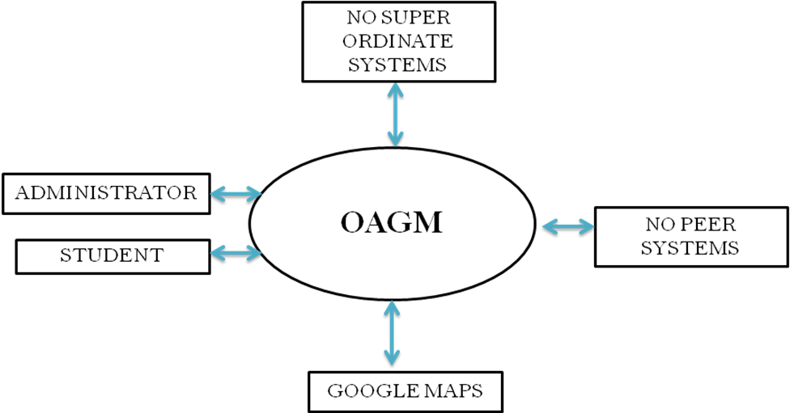

Level-0 / Context Diagram:

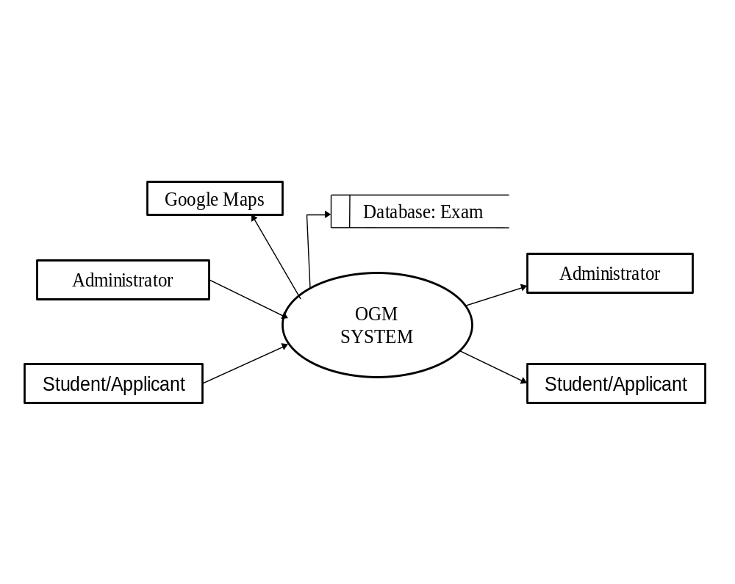

Level-1 DFD for Administrator:

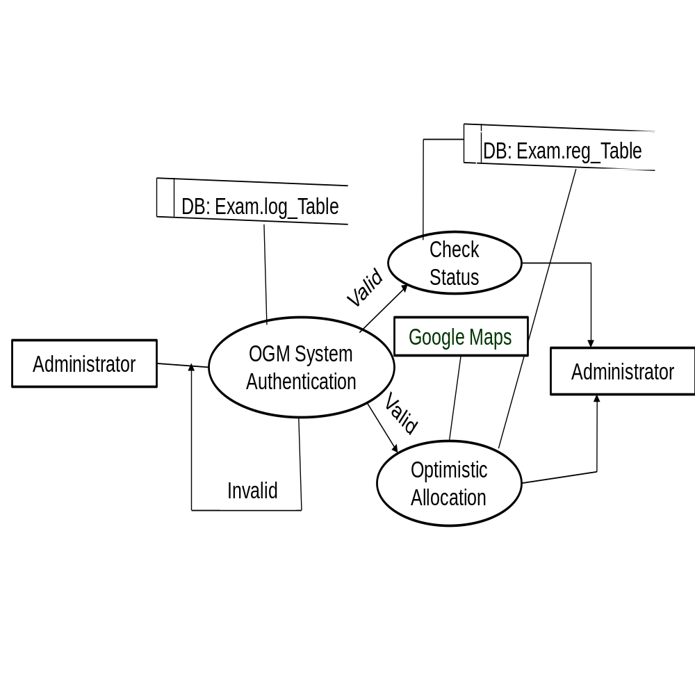

Level-1 DFD for Student/Applicant:

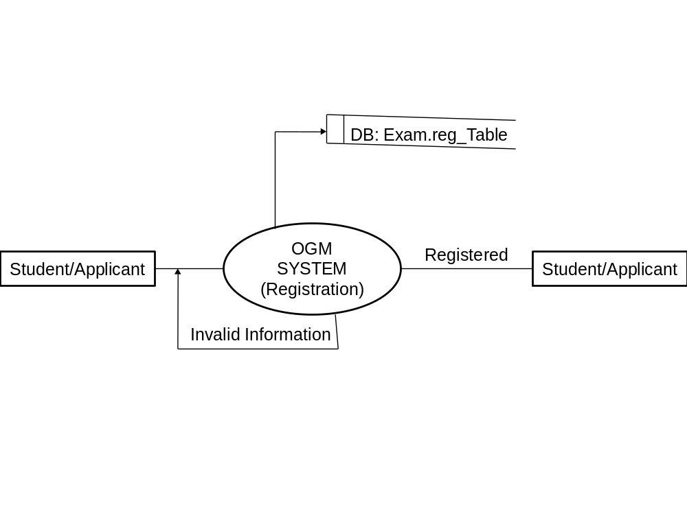

Level-2 DFD for Student / Applicant:

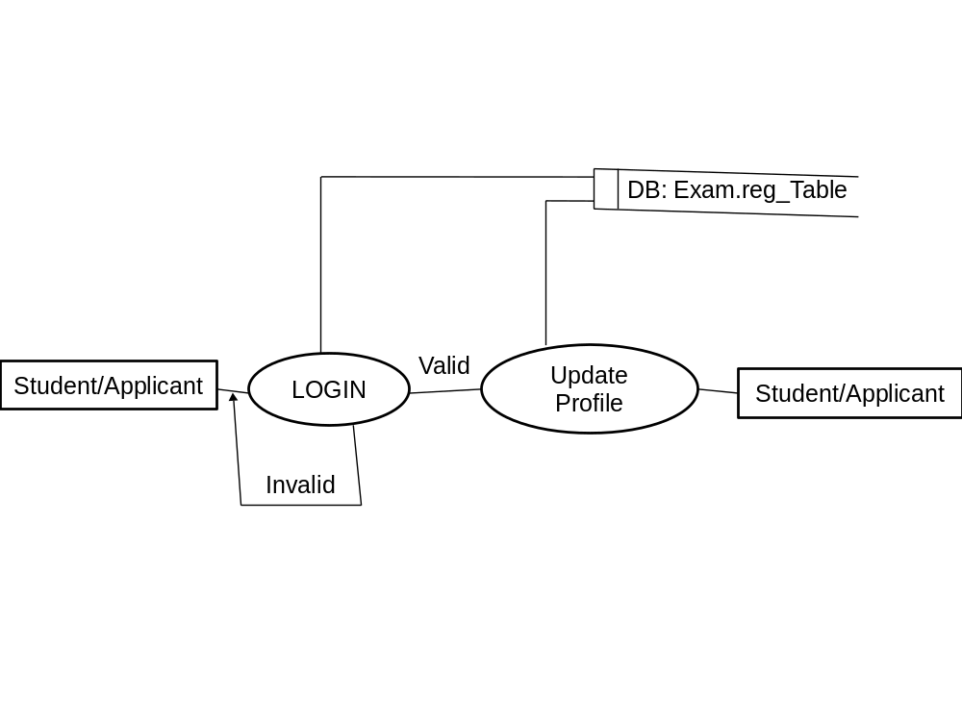

3.5.2 ER-Diagram:

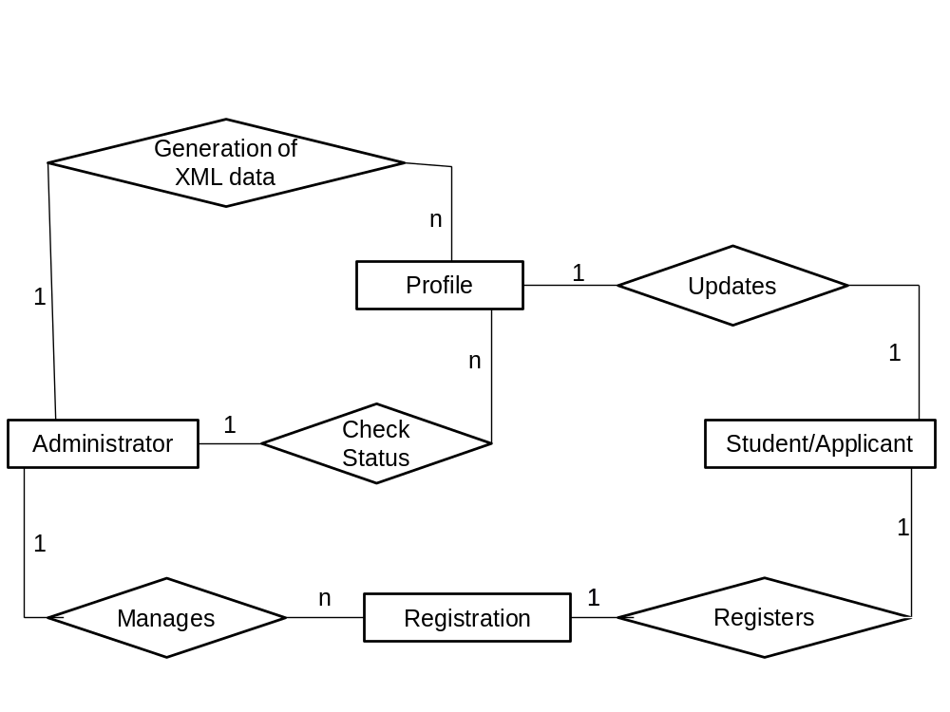

3.5.2 UML-Diagrams(UNIFIED MODELING LANGUAGE DIAGRAMS):

  - The unified modeling language allows the software engineer to express an analysis model using the modeling notation that is governed by a set of syntactic semantic and pragmatic rules.
  - A UML system is represented using five different views that describe the system from distinctly different perspective. Each view is defined by a set of diagram, which is as follows.
  - User Model View
    - This view represents the system from the users perspective.
    - The analysis representation describes a usage scenario from the end-users perspective.
Structural model view
- In this model the data and functionality are arrived from inside the system.
- This model view models the static structures.
Behavioral Model View
It represents the dynamic of behavioral as parts of the system, depicting the interactions of collection between various structural elements described in the user model and structural model view.
Implementation Model View
In this the structural and behavioral as parts of the system are represented as they are to be built.
Environmental Model View
In this the structural and behavioral aspects of the environment in which the system is to be implemented are represented.
UML is specifically constructed through two different domains they are
- UML Analysis modeling, which focuses on the user model and structural model views of the system?
- UML design modeling, which focuses on the behavioral modeling, implementation modeling and environmental model views.

Use case diagram for Admin:
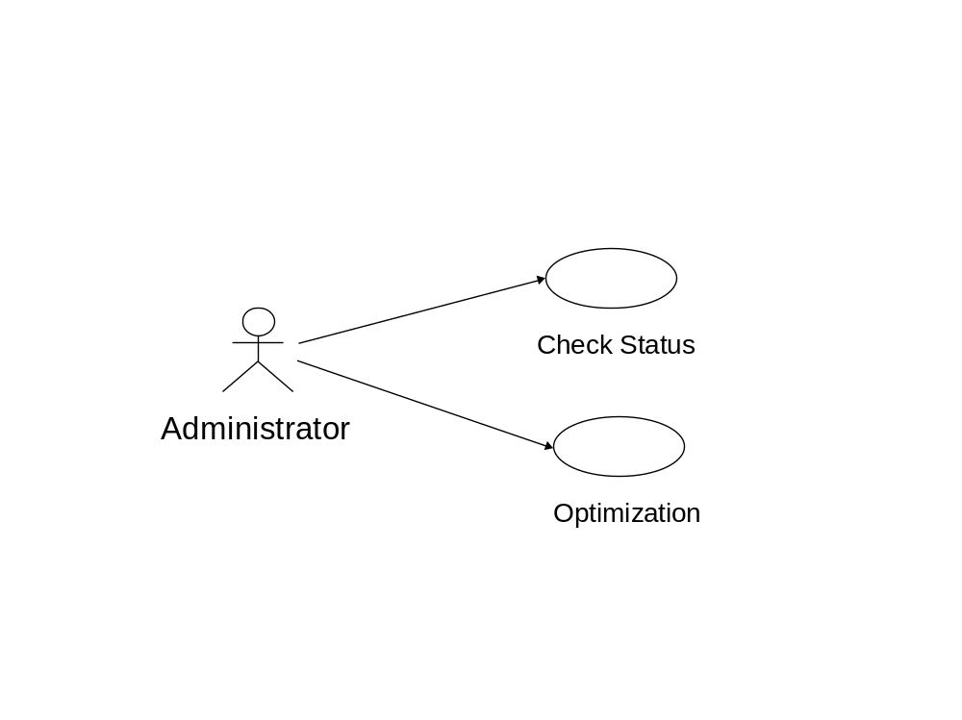

Use case diagram for Student / Applicant:
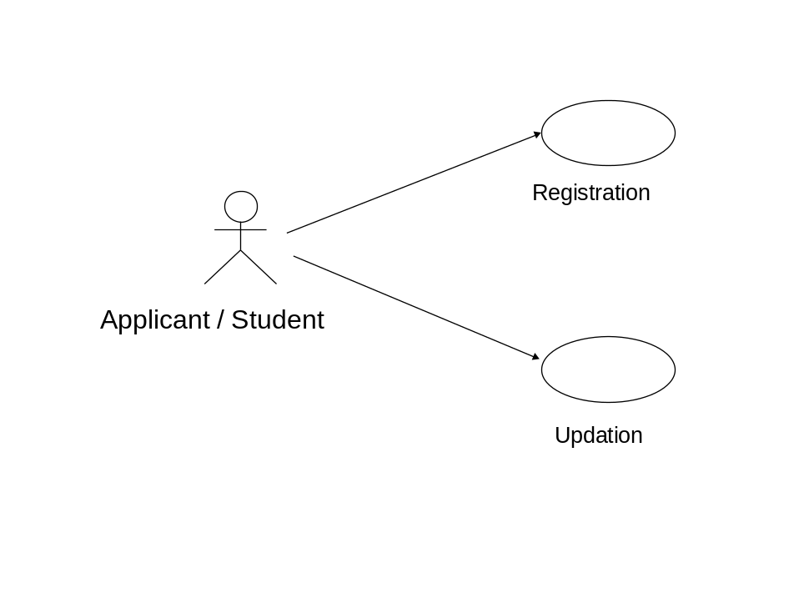

Class diagram:
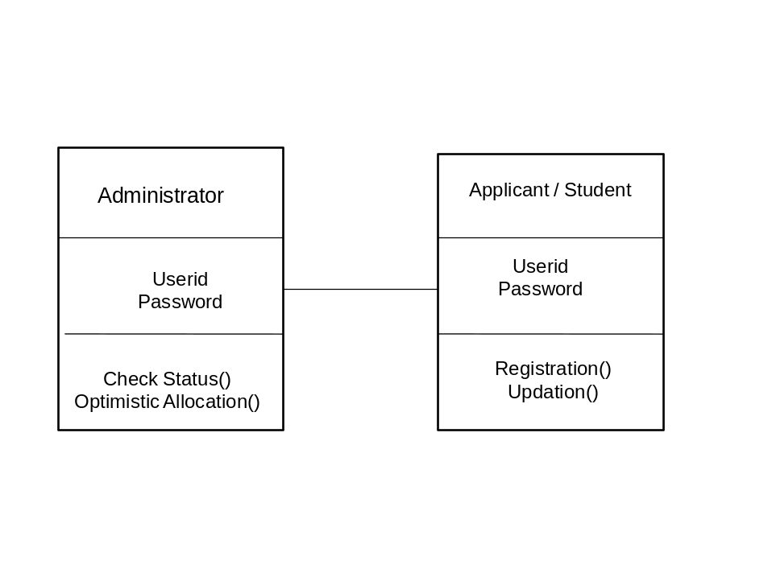

State Diagram:
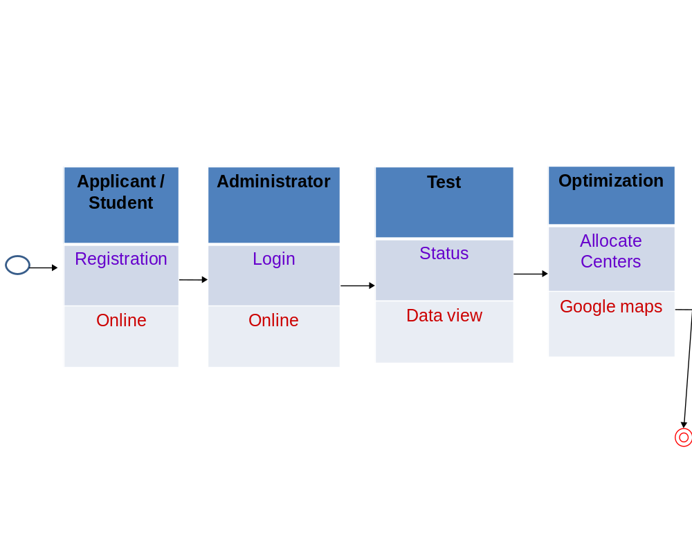

Activity Diagram for Administrator:
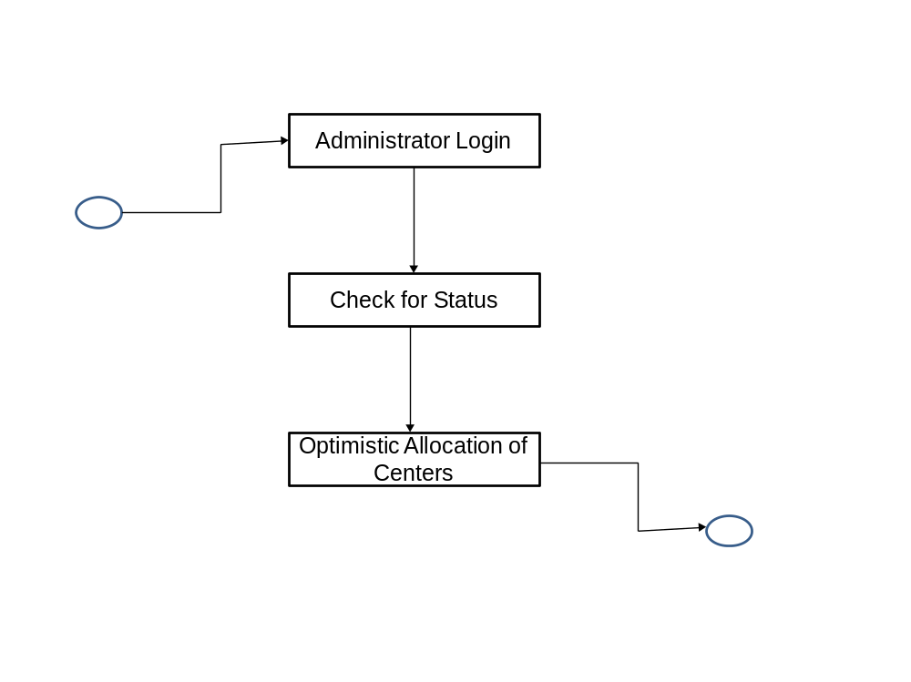

Sequence Diagram for Administrator:
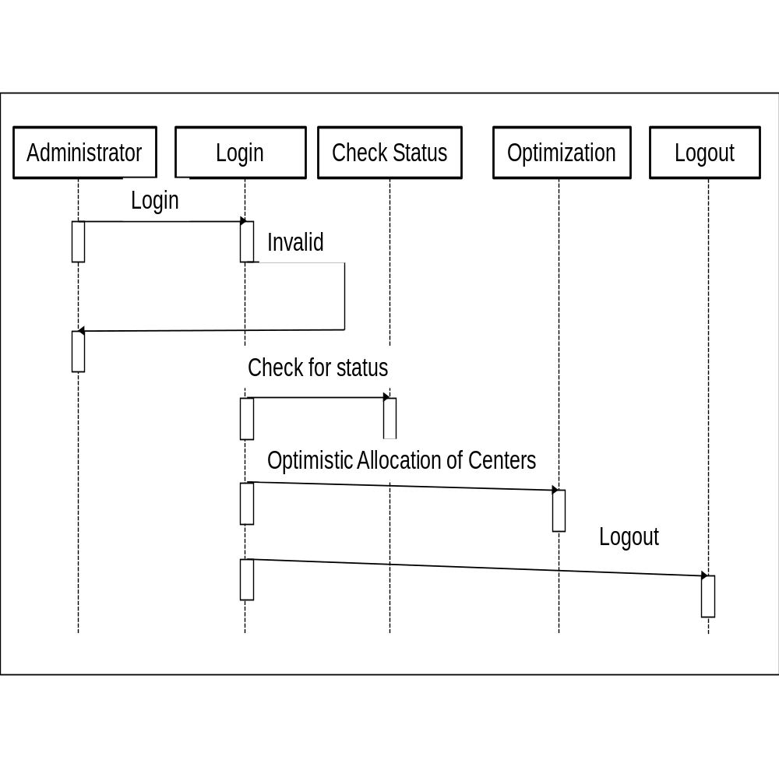

Sequence Diagram for Student / Applicant:
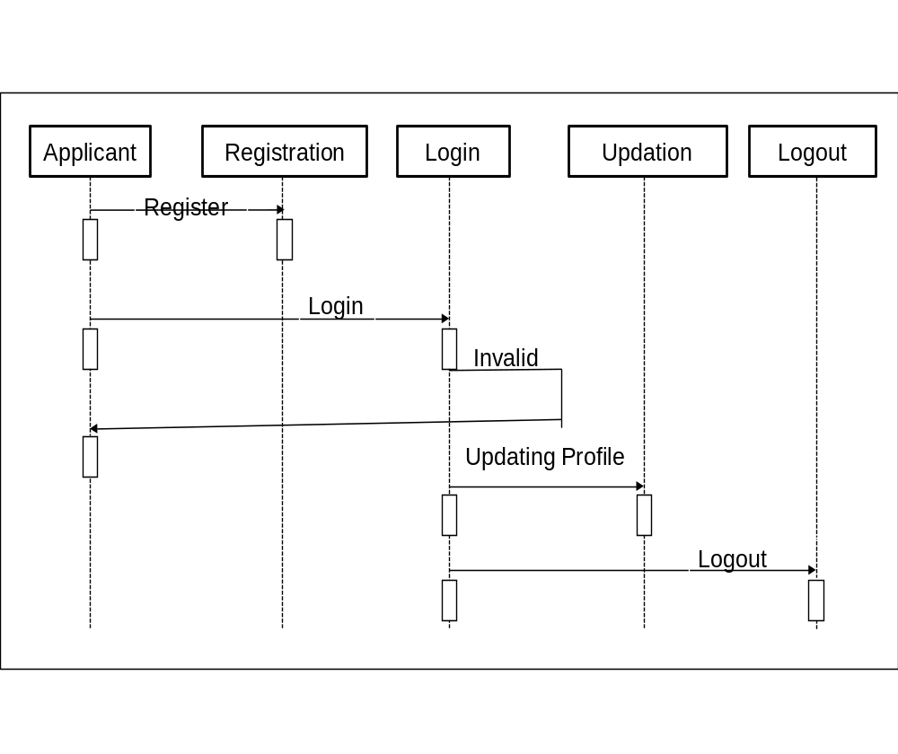

Component Diagram:
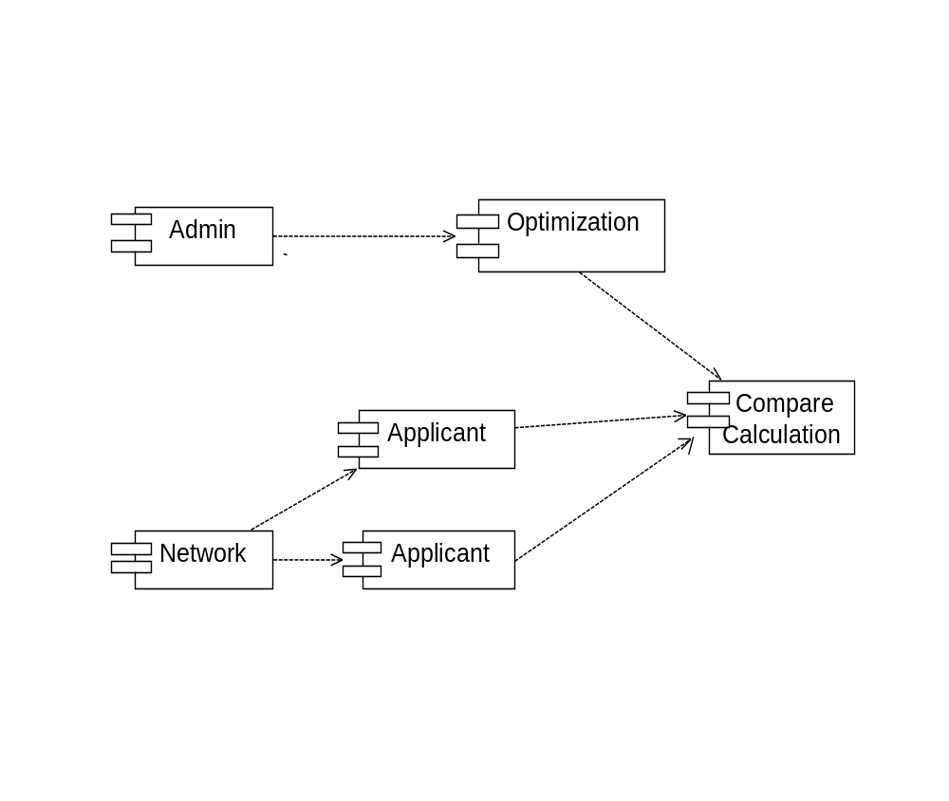

  - Data Tables:

1.Student Registration Table:

Name | Type | Description
Sname | Varchar(25) | Candidate name
Gender | Varchar(5) | Gender
child_of | Varchar(20) | Father name
Examtype | Varchar(5) | Exam Type
Dob | Date | Date of Birth
Age | Int(5) | Candidate Age
Caste | Varchar(15) | Candidate caste
Cellno | Text | Mobile Number
Email | Number | Email Address
Image | Blob | Candidate Image
Password | Int(8) | PassWord
Lat | Float(10,4) | Latitude
Lng | Float(1,4) | Longitude
Imgdesc | Varchar(30) | Image address
District | Varchar(15) | Candidate district
Address | Varchar(50) | Candidate Address
Id | Int(3) | Candidate Identity

2.Cros table:
Name | Type | Description
sid | Varchar(11) | Id
sname | Varchar(15) | Exam Type

3.Regist table:

Name | Type | Description
lat | Varchar(10,6) | Latitude
lng | Float(10,6) | Longitude
p | point | Spatial Point
etype | Varchar(20) | Exam type
cluster | Varchar(20) | Clusters
avglat | Float(10,6) | Average
avglng | Float(10,6) | Average

ALGORITHM

DENSITY BASED SPATIAL CLUSTERING ON APPLICATIONS USING NOISE

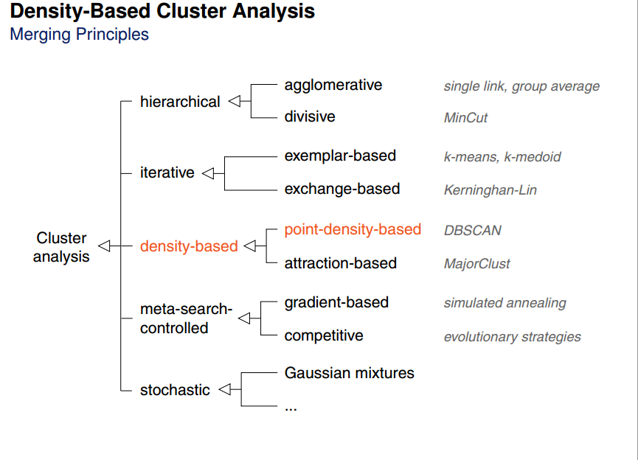

Why dbscan over other(kmeans)?
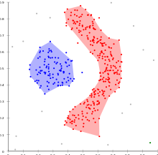
DBSCAN can find non-linearly separable clusters. This dataset cannot be adequately clustered with k-means or Gaussian Mixture EM clustering.

WHAT IS DBSCAN
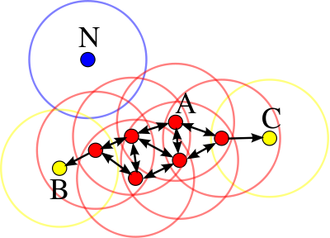

In this diagram, minPts = 3. A and the other red points are core points, because at least three points surround it in an ε radius. Because they are all reachable from one another, they form a single cluster. Points B and C are not core points, but are reachable from A (via other core points) and thus belong to the cluster as well. Point N is a noise point that is neither a core point nor density-reachable.

DBSCAN ALGORITHM
DBSCAN(D, eps, MinPts)
C = 0
for each unvisited point P in dataset D
mark P as visited
NeighborPts = regionQuery(P, eps)
if sizeof(NeighborPts) < MinPts
mark P as NOISE
else
C = next cluster
expandCluster(P, NeighborPts, C, eps, MinPts)

expandCluster(P, NeighborPts, C, eps, MinPts)
add P to cluster C
for each point P' in NeighborPts
if P' is not visited
mark P' as visited
NeighborPts' = regionQuery(P', eps)
if sizeof(NeighborPts') >= MinPts
NeighborPts = NeighborPts joined with NeighborPts'
if P' is not yet member of any cluster
add P' to cluster C

regionQuery(P, eps)
return all points within P's eps-neighborhood (including P)
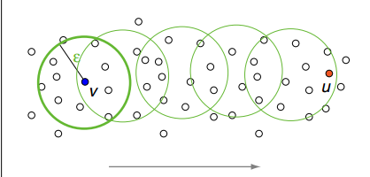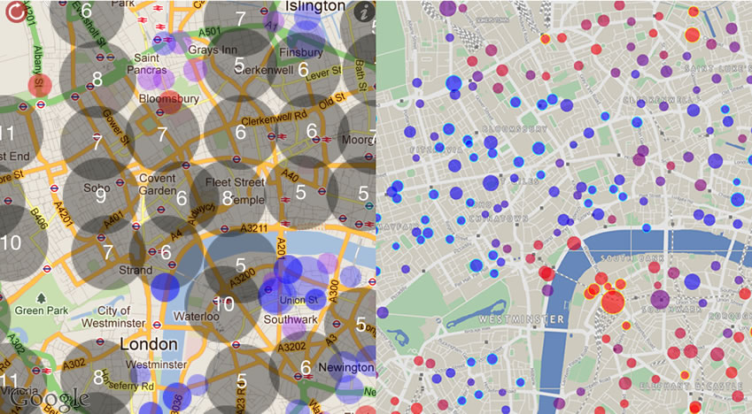

IMPLEMENTATION

4. IMPLEMENTATION

4.1 MODULES DESCRIPTION:
1. ADMINISTRATOR
This Module is divided into different sub-modules.
Check Status
Optimistic Allocation
This module deals with the functionalities of System Administrator such like check status regarding the Applicants registrations done from various locations for various type of exams. Admin is responsible for extraction of location-based details from Google maps. Finally, Admin allocates optimum number of centers for the exams based on the total number of student registrations belonging to diverse geographical locations using Google maps.

2. STUDENT / APPLICANT
This Module is divided into different sub-modules.
Registration
Updation
Using our application student/applicant can register for any type of competitive exams based on his/her eligibility criteria, once the registration has completed a unique username and password will be send to his/her mail id, once the username and password has received by the student/applicant that can be used for further updation of profile and also it is used for the checking his/her exam status.

4.2 Sample Code:

connection.php:
<?php
$mysql_hostname = "localhost";
$mysql_user = "Sai";
$mysql_password = "Rams";
$mysql_database = "sai";
$bd = mysql_connect($mysql_hostname, $mysql_user, $mysql_password) or die("Could not connect database");
$bdcon=mysql_select_db($mysql_database, $bd) or die("Could not select database");
?>

newregister.php:
<?php
include('connection.php');
if(isset($_POST['submit']))
{
session_start();
$sname=$_POST['username'];
$pwd=$_POST['password'];
$_SESSION['name']=$_POST['username'];
$_SESSION['pwd']=$_POST['password'];
$sql="SELECT sname,dob,cellno,examtype,address,email FROM reg where sname='$sname' and password='$pwd' ";
$result = mysql_query($sql) or die("SELECT Error: ".mysql_error());
$count=mysql_num_rows($result);
if($count==1)
{
while($info = mysql_fetch_array( $result ))
{
$_SESSION['name']=$info['sname'];
$_SESSION['db']=$info['dob'];
$_SESSION['ce']=$info['cellno'];
$_SESSION['et']=$info['examtype'];
$_SESSION['adr']=$info['address'];
$_SESSION['mail']=$info['email'];
print "<table border=1 ALIGN='center' bgcolor='pink'>";
print "<tr>";
print "<td>NAME</td>";
print "<td>".$info['sname']."</td>";
print "</tr>";
print "<tr>";
print "<td>DATE OF BIRTH</td>";
print "<td>".$info['dob'] . " </td>";
print "</tr>";
print "<tr>";
print "<td>CELLNO</td>";
print "<td>".$info['cellno'] . "</td> ";
print "</tr>";
print "<tr>";
print "<td>EXAMTYPE</td>";
print "<td>".$info['examtype'] . "</td> ";
print "</tr>";
print "<tr>";
print "<td>ADDRESS</td>";
print "<td>".$info['address'] . "</td>";
print "</tr>";
print "<tr>";
print "<td>E-MAIL</td>";
Print "<td>".$info['email'] . "</td>";
Print "</tr>";
print "</tr>";
Print "</table>";
}
echo "<br>";
echo "<br>";
echo "<center>";
echo "<h3>DO YOU WANT UPDATE YOUR PROFILE NOW?<a href='proupdate1.php'>UPDATE</a></h3>";
echo "<h3>R U SURE U WANT TO GO BACK?<a href='maindemo.html'>YES</a></h3>";
echo "</center>";
}
else
{
echo "<center>";
echo "<h3>YOU ARE NOT A VALID USER</h3>";
echo "<h3><a href='updatelogin.html'>CLICK HERE FOR RELOGIN</a></h3>";
echo "<h3><a href='maindemo.html'>CLICK HERE FOR HOME</a></h3>";
echo "</center>";
}
}
?>

mappi.php
<?php
//session_start();
include('connection.php');

$sql="SELECT * FROM persons where sid=915";

$result = mysql_query($sql) or die("SELECT Error: ".mysql_error());

if(!$result)
{
die("SELECT Error: ".mysql_error());
}

$dom =new DOMDocument('1.0','UTF-8');

//Create the root KML element and append it to the Document
$rnode = $dom->createElementNS('http://earth.google.com/kml/2.1','kml');
$rootnode = $dom->appendChild($rnode);

//Create a Folder element and append it to the KML element
//$fnode = $dom->createElement('Folder');
//$folderNode = $parNode->appendChild($fnode);

//Iterate through the MySQL results
//$row = @mysql_fetch_assoc($result);

//Create a Placemark and append it to the document
$pnode = $dom->createElement("persons");
$rpnode = $rootnode->appendChild($pnode);

header("Content-type: text/xml");

while ($row = @mysql_fetch_assoc($result)){
// ADD TO XML DOCUMENT NODE
$childnode = $dom->createElement("person");
$newnode = $rpnode->appendChild($childnode);
$newnode->setAttribute("sid", $row['sid']);
$newnode->setAttribute("sname", $row['sname']);
$newnode->setAttribute("etype", $row['etype']);
$newnode->setAttribute("addr", $row['addr']);
$newnode->setAttribute("lat", $row['lat']);
$newnode->setAttribute("lng", $row['lng']);
}

$kmlOutput = $dom->saveXML();
echo $kmlOutput;

//assign the KML headers.
//header('Content-type: application/vnd.google-earth.kml+xml');
//header("Content-type: text/xml");

?>

locatemap.php

<!DOCTYPE html >

<?php
session_start();
include('connection.php');

//if(isset($_POST['submit']))
//{
//$_SESSION['sid']=$_POST['idd'];

//}
?>

//<html xmlns="http://www.w3.org/1999/xhtml">
<head>
<meta name="viewport" content="initial-scale=1.0, user-scalable=no" />
<meta http-equiv="content-type" content="text/html; charset=UTF-8"/>
<title>PHP/MySQL & Google Maps Example</title>

<script type="text/javascript" src="http://maps.googleapis.com/maps/api/js?sensor=false">
</script>

<script type="text/javascript">
//<![CDATA[

var customIcons = {

emp: {
icon: 'http://labs.google.com/ridefinder/images/mm_20_blue.png',
shadow: 'http://labs.google.com/ridefinder/images/mm_20_shadow.png'
},

unemp: {
icon: 'http://labs.google.com/ridefinder/images/mm_20_red.png',
shadow: 'http://labs.google.com/ridefinder/images/mm_20_shadow.png'
}
};

function load() {
//lat and lng of warangal district 18.005623, 79.557243
var map = new google.maps.Map(document.getElementById("map"), {
center: new google.maps.LatLng(17.71, 79.15),
zoom: 13,
mapTypeId: 'roadmap'
});

var infoWindow = new google.maps.InfoWindow;

// Change this depending on the name of your PHP file
downloadUrl("mappi.php", function(data) {

var xml = data.responseXML;
var per = xml.documentElement.getElementsByTagName("person");

for (var i = 0; i < per.length; i++) {

var sid = per[i].getAttribute("sid");
var sname = per[i].getAttribute("sname");
var etype= per[i].getAttribute("etype");
var address = per[i].getAttribute("addr");
var point = new google.maps.LatLng(
parseFloat(per[i].getAttribute("lat")),parseFloat(per[i].getAttribute("lng")));
var html = "<b>" + sname + "</b> <br/>" + address + "</b> <br/>" + sid;
var icon = customIcons[etype] || {};
var marker = new google.maps.Marker({
map: map,
position: point,
icon: icon.icon,
shadow: icon.shadow
});
bindInfoWindow(marker, map, infoWindow, html);
}
});
}

function bindInfoWindow(marker, map, infoWindow, html)
{
google.maps.event.addListener(marker, 'click', function()
{
infoWindow.setContent(html);
infoWindow.open(map, marker);
});
}

function downloadUrl(url, callback)
{
var request = window.ActiveXObject ? new ActiveXObject('Microsoft.XMLHTTP') :new XMLHttpRequest;
request.onreadystatechange = function() {
if (request.readyState == 4) {
request.onreadystatechange = doNothing;
callback(request, request.status);
}
};
request.open('GET', url, true);
request.send(null);
}

function doNothing() {} //]]>

</script>
</head>
<body onload="load()">
<div id="map" style="width: 1000px; height: 500px"></div>
</body>
</html>

SCREEN SHOTS

5.SCREEN SHOTS
Student Registration Page:

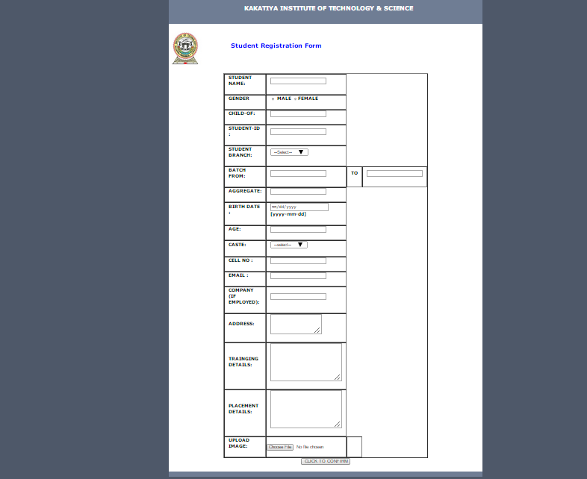

Mapping student address on Google maps:

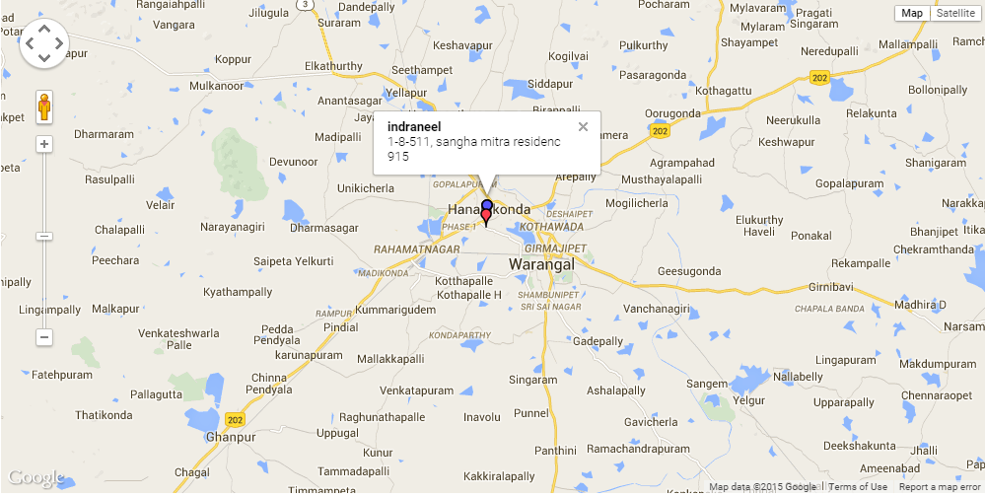

XML FORMAT

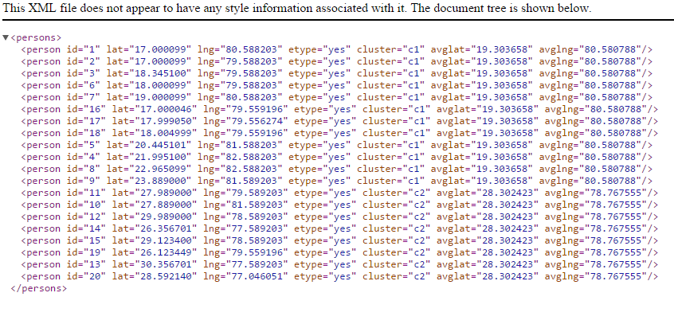

Representation of Different Clusters:

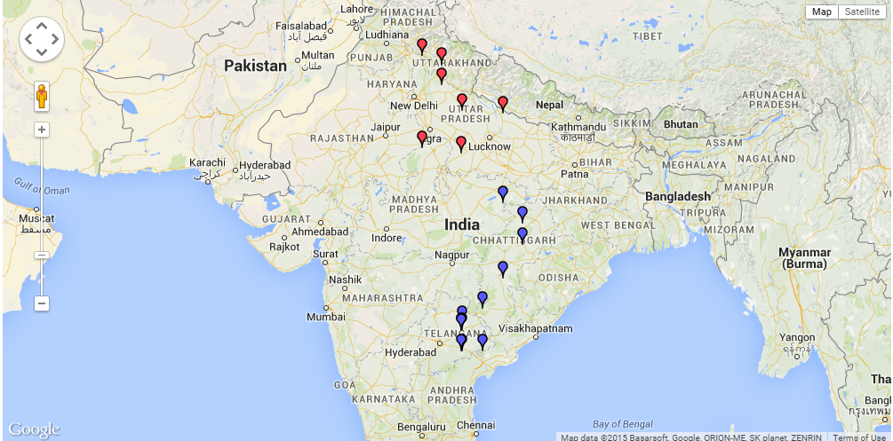

Final exam centers:

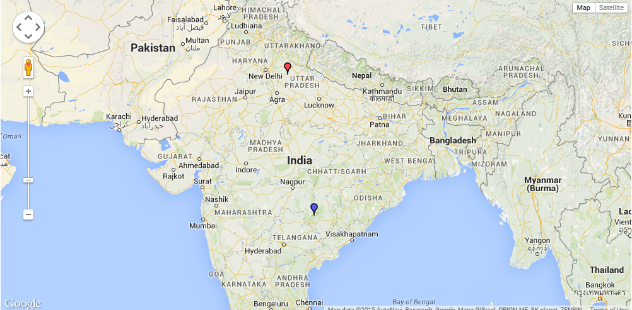

TESTING

6. TESTING

INTRODUCTION:
Software testing is a critical element of software quality assurance and represents the ultimate review of specification, design and coding. In fact, testing is the one step in the software engineering process that could be viewed as destructive rather than constructive.
A strategy for software testing integrates software test case design methods into a well-planned series of steps that result in the successful construction of software. Testing is the set of activities that can be planned in advance and conducted systematically. The underlying motivation of program testing is to affirm software quality with methods that can economically and effectively apply to both strategic to both large and small-scale systems.

STRATEGIC APPROACH TO SOFTWARE TESTING
The software engineering process can be viewed as a spiral. Initially system engineering defines the role of software and leads to software requirement analysis where the information domain, functions, behavior, performance, constraints and validation criteria for software are established. Moving inward along the spiral, we come to design and finally to coding. To develop computer software we spiral in along streamlines that decrease the level of abstraction on each turn.

A strategy for software testing may also be viewed in the context of the spiral. Unit testing begins at the vertex of the spiral and concentrates on each unit of the software as implemented in source code. Testing progress by moving outward along the spiral to integration testing, where the focus is on the design and the construction of the software architecture. Talking another turn on outward on the spiral we encounter validation testing where requirements established as part of software requirements analysis are validated against the

software that has been constructed. Finally we arrive at system testing, where the software and other system elements are tested as a whole.

UNIT TESTING

MODULE TESTING

SUB-SYSTEM TESING

SYSTEM TESTING

ACCEPTANCE TESTING
Component Testing
Integration Testing

User Testing

UNIT TESTING
Unit testing focuses verification effort on the smallest unit of software design, the module. The unit testing we have is white box oriented and some modules the steps are conducted in parallel.
1. WHITE BOX TESTING

- All independent paths have been exercised at least once
- All logical decisions have been exercised on their true and false sides
- All loops are executed at their boundaries and within their operational bounds
- All internal data structures have been exercised to assure their validity.

2. BASIC PATH TESTING
Established technique of flow graph with Cyclamate complexity was used to derive test cases for all the functions. The main steps in deriving test cases were:
Use the design of the code and draw correspondent flow graph.
Determine the Cyclamate complexity of resultant flow graph, using formula:
V (G) =E-N+2 or
V (G) =P+1 or
V (G) =Number of Regions
Where V (G) is Cyclamate complexity,
E is the number of edges,
N is the number of flow graph nodes,
P is the number of predicate nodes.
Determine the basis of set of linearly independent paths.

3. CONDITIONAL TESTING
In this part of the testing each of the conditions were tested to both true and false aspects. And all the resulting paths were tested. So that each path that may be generate on particular condition is traced to uncover any possible errors.

4. DATA FLOW TESTING
This type of testing selects the path of the program according to the location of definition and use of variables. This kind of testing was used only when some local variable were declared. The definition-use chain method was used in this type of testing. These were particularly useful in nested statements.

5. LOOP TESTING
- All the loops were tested at their limits, just above them and just below them.
- All the loops were skipped at least once.
- For nested loops test the inner most loop first and then work outwards.
- For concatenated loops the values of dependent loops were set with the help of connected loop.
- Unstructured loops were resolved into nested loops or concatenated loops and tested as above.
Each unit has been separately tested by the development team itself and all the input have been validated.

6.1 TEST CASES:

Test Case ID: | 1
Test Case Name | Software Installation Test
Purpose: | To check whether the required Software is installed on the systems
Input: | Run the Wamp server
Expected Result: | Should Display the command prompt.
Actual Result: | Displays the command prompt for writing the query for our requirement.
Result: | Success

Test Case ID: | 2
Test Case Name | Registration of a student.
Input: | Filled registration form.
Expected Result: | Should given success message for registration.
Actual Result: | Opens the form including success message.
Result: | Sucesses

Test Case ID: | 3
Test Case Name | optimization
Input: | All the candidates registrations including address of each student.
Expected Result: | Should display a google map on the screen indiacting each district information regarding total number of registrations and centers required.
Actual Result: | displays the map as we required.
Result | Success

CONCLUSION & FUTURE WORK
7.CONCLUSION & FUTURE WORK

It has been a great pleasure for me to work on this exciting and challenging project. This project proved good for me as it provided practical knowledge of not only programming in PHP and MySQL web based application and no some extent Windows Application and MySQL, but also about all handling procedure related with “Optimistic Allocation of Exam Centers on Google Maps Manager”. It also provides knowledge about the latest technology used in developing web enabled application and client server technology that will be great demand in future. This will provide better opportunities and guidance in future in developing projects independently.

BENEFITS:
The project is identified by the merits of the system offered to the user. The merits of this project are as follows: -
- It’s a web-enabled project.
- This project offers user to enter the data through simple and interactive forms. This is very helpful for the client to enter the desired information through so much simplicity.
- The user is mainly more concerned about the validity of the data, whatever he is entering. There are checks on every stages of any new creation, data entry or updating so that the user cannot enter the invalid data, which can create problems at later date.
- Sometimes the user finds in the later stages of using project that he needs to update some of the information that he entered earlier. There are options for him by which he can update the records. Moreover there is restriction for his that he cannot change the primary data field. This keeps the validity of the data to longer extent.
- User is provided the option of monitoring the records he entered earlier. He can see the desired records with the variety of options provided by him.

- From every part of the project the user is provided with the links through framing so that he can go from one option of the project to other as per the requirement. This is bound to be simple and very friendly as per the user is concerned. That is, we can sat that the project is user friendly which is one of the primary concerns of any good project.
- Data storage and retrieval will become faster and easier to maintain because data is stored in a systematic manner and in a single database.
- Decision making process would be greatly enhanced because of faster processing of information since data collection from information available on computer takes much less time then manual system.
- Allocating of sample results becomes much faster because at a time the user can see the records of last years.
- Easier and faster data transfer through latest technology associated with the computer and communication.
- Through these features it will increase the efficiency, accuracy and transparency,

LIMITATIONS:
- The size of the database increases day-by-day, increasing the load on the database back up and data maintenance activity.
- Training for simple computer operations is necessary for the users working on the system.

BIBLIOGRAPHY
8.BIBLIOGRAPHY

REFERENCES:

PHP:

Learning PHP 5 - David Sklar
The Complete Reference - McGraw Hill
Core PHP programming - Leo Atkinson, Zeev Surasky

MySQL:

The Complete Reference - Vaswani

- FOR PHP INSTALLATION
www.phpwamp.com
www.php.net/manul/en/install.windows.php
- FOR DEPLOYMENT AND PACKING ON SERVER
www.wampserver.com
www.w3schools.com
- FOR MYSQL
www.dev.mysql.com
- FOR PHP
www.php-manual.com

